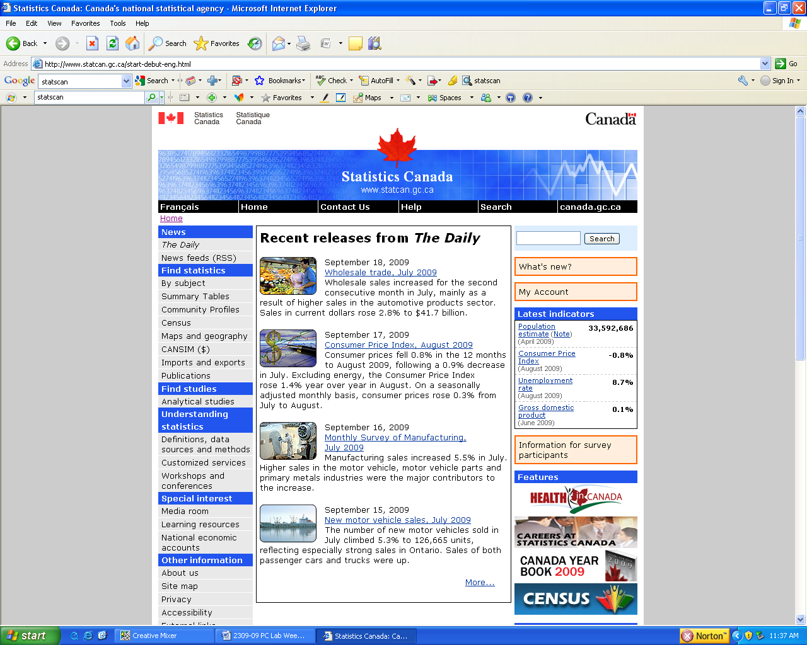

**MKTG 2341-09 PC Lab Week 3: Statistics Canada and Longitudinal Data**

**TASK #1: Use the *Community Profiles* section of StatsCan’s website to answer the following questions.**

1. What was the number of *couple families with children* in the City of Vancouver in 2006?
2. Was this more or less than the number of couple families without children in Vancouver in 2006?
3. Did the total population of the City of Vancouver grow by a smaller or larger percentage than the total population of British Columbia between 2001 and 2006? Cite the two percentages below.
4. The postal code for BCIT’s Burnaby campus is V5G 3H2. What census tract is it in?
5. How many private dwellings were there in this census tract in 2006?
6. Did the population in this census tract increase or decrease between 2001 and 2006 and by what amount?
7. What type of housing is most prevalent in this census tract and what percentage of occupied private dwellings do they represent?
8. Is the composition of dwelling types in this census tract similar to or different from the composition of dwelling types in the Vancouver Metropolitan area?

**TASK #2: Use the *Statistics by Subject* section of StatsCan’s website to answer the following questions.**

1. What was the change (in dollars) in retail store sales of girls', boys' and infants' clothing and accessories in Canada between 2004 and 2008?
2. Copy and past the URL for the data table you used to determine this statistic.
3. Approximately how much more was spent on women’s clothing and accessories than men’s clothing and accessories in 2008?
4. Between 2000 and 2004, did the number of trips in Canada taken by BC residents increase or decrease?
5. What is the URL for the webpage that gave you this information?
6. Find the following PDF document and paste the URL where it can be found below: *Self-reported Violent Delinquency and the Influence of School, Neighbourhood and Student Characteristics*
7. What percentage of students in Grades 7 through 9 in Toronto reported at least one act of violent delinquency in 2006?
8. What percentage of the survey respondents’ friends accept criminal behaviour?

**TASK #3: Use the *Summary Tables* section of StatsCan’s website to answer the following questions.**

1. What was the average expenditure per household in Vancouver on clothing in 2007?
2. Is this more than or less than the amount spent on clothing among households in Edmonton?
3. What is the URL for the webpage that gave you this information?

**TASK #4: Use the *Search Function* on StatsCan’s website to answer the following questions.**

1. In a 2008 edition of *The Daily* there is information about beer and wine consumption in Canada. What beverage remains the alcoholic drink of choice among Canadians?
2. Is the dominance of beer increasing or decreasing?
3. How many billions of dollars worth of wine were solid in Canada in 2006/2007?
4. From this edition of The Daily you can link to a data table that shows the sales of alcoholic beverages by volume, value and per capita across Canada and by each province and territory. How much money did British Columbians spend on wine (in dollar value) in 2008?
5. What was the per capita expenditure on wine among BC residents 15 years of age and older in 2008?
6. What is the URL of the table that gave you this information?